Find two errors in section IV of Lecture notes (NumericalMethodsMD.pdf).

1. There is an error in the definition of the Lennard-Jones function in the notes.

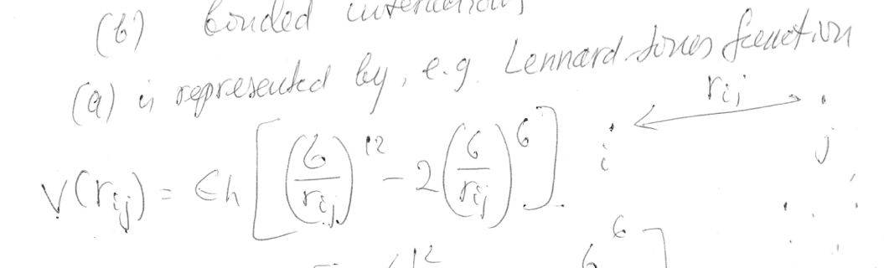

The commonly used expression for the Lennard-Jones potential is

V LJ = 4 ε [ ( σ r ) 12 − ( σ r ) 6 ] ,             ( 1 ) {\displaystyle V_{\text{LJ}}=4\varepsilon \left[\left({\frac {\sigma }{r}}\right)^{12}-\left({\frac {\sigma }{r}}\right)^{6}\right],~~~~~~(1)} 

where *r {\displaystyle r} r* is the distance between two interacting particles, ε {\displaystyle \varepsilon } ε is the depth of the potential well (usually referred to as 'dispersion energy'), and σ {\displaystyle \sigma } σ is the distance at which the particle-particle potential energy *V {\displaystyle V} V* is zero (often referred to as 'size of the particle').

1. The derivation of Fi,x does not make sense. The use if the absolute value function is wrong.

